**Query 1: Find the maximum and minimum enrolment across all sections that had enrolment**

**We want to find the biggest and smallest number of students in any section.**

🔹 Inner Part: This counts how many students are in each section, we **group** the data and we count how many student IDs are in each group → this gives us the **enrolment**

🔹 Outer Part: It looks at the results from the inner part (which we called **section enrolments**) and picks the **largest number** (MAX) and the **smallest number** (MIN) of students in those sections.

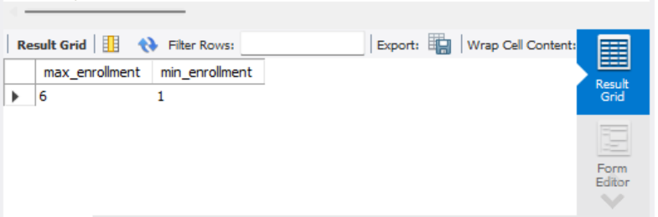

**-- Query 2: Find all sections that had the maximum enrolment (along with the enrolment)**

**-- We use the previous subquery again and compare each section's count to the max value**

**Query 3.1: Include sections with no students using scalar subquery (returns 0 for sections not in takes)**

**-- Insert extra section data if needed**



**-- Query 3.2: Include sections with no students using LEFT OUTER JOIN**

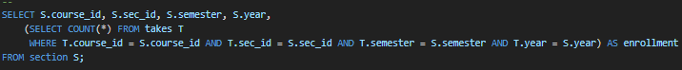

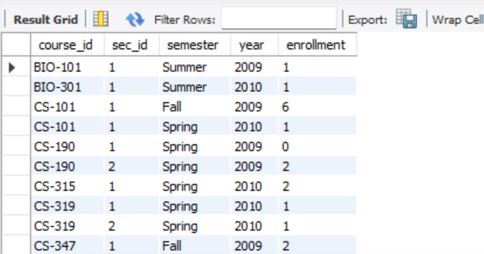

**-- Query 4: Find all courses whose identifier starts with "CS-1"**



**-- Query 5.1: Instructors who have taught all "CS-1%" courses using NOT EXISTS with EXCEPT**

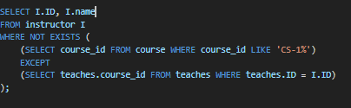

**-- Query 5.2: Same query using COUNT matching**

**-- Query 6: Insert each instructor as student with tot_creds = 0, same department**

**-- Query 7: Delete those newly added students (tot_cred = 0 and ID is in instructor)**

**-- Query 8: Update tot_creds of each student based on total credits from passed courses**

**A pass grade is A, B, C, D**

**-- Query 9: Update instructor salary = 10000 * number of sections taught**

**-- Advanced Section**

**-- Query 1: View of fail grades that are not overridden**

**-- Query 2: Students with 2 or more non-overridden F grades**

**-- Query 3: CPI calculation using grade points**

**-- Insert mapping**

**-- Compute CPI**

**-- Query 4: Find rooms with multiple assignments at the same time**

**-- Query 5: Create view for faculty**

**-- Query 6: Create view for CS instructors**



**-- Query 7: Insert tuple into views**

**Faculty view allows insertion as it’s directly mapped to base table**

**-- Query 8: Grant permission to friend to view student data**

**-- Query 9: Grant permission to all users on faculty view**

